2.5 Requirements Manual for “Buy” Parts

2.5.1 Categorise “buy” parts into mechanical and electrical

Electrical BUY Parts

- Microcontroller (MCU)
- Load Cell Connector
- Load Cell Interface Port
- Noise and Low-pass Filter
- Amplifier
- Analog to Digital Converter (ADC) Module
- Cell Excitation Regulator
- Touchscreen Display
- Latching Push Button
- Internal Memory Module
- USB-A Port
- Power Regulator
- USB-C Port
- Battery Charging Circuit
- Battery
- Misc

Total Electrical Buy Parts: 16

Mechanical BUY Parts

- Protective Carrying Case
- Foam
- 1-Panel Frame
- M4 x 12 Button Head Screw
- M3 x 10 Button Head Screw
- M3 x 8 Button Head Screw
- ST3.5x9.5 Tapping Screw
- M3 Hex Nuts
- M4 Washer
- M3 Washer
- Roll 20mm Wide Velcro
- PVC Foam Tape
- M4X9.2
Total Mechanical Buy Parts: 13

Total BUY parts = 29
2.5.2 Table for Buy parts

Electrical parts

No. | Part | Qty. | Requirements |  | Justification
1 | Microcontroller (MCU) | 1 | - 5 V operation; ≥16 MHz clock;  - 32 kB Flash, 2 kB SRAM; SPI/I²C/UART interfaces;  - industrial temperature −40…85 °C. |  | With a committed MCU, deterministic timing for ADC sampling is made possible and steady handling of user interface, force computations, and communication procedures is guaranteed—something non-real-time processors would not be dependable with.
2 | Load Cell Connector | 1 | - Shielded multi-core cable;  - compatible with Innovatest load-cell wiring;  - PVC/PUR jacket;  - −25…80 °C temperature rating;  - low-resistance copper conductors. | 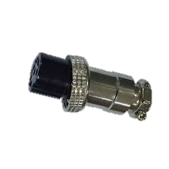 | By lowering EMI coupling and guaranteeing a physically secure link under field vibrations, a devoted shielded connector helps to preserve high signal integrity.
3 | Load Cell Interface Port | 1 | - Panel-mount 5-contact connector;  - IP67 protection; nickel-plated brass/PA housing;  - rated current ≥  2 A;  - screw-lock interface. | 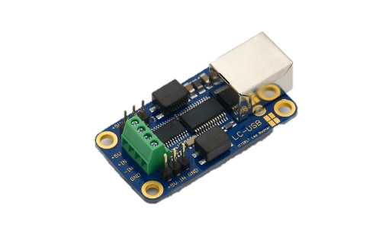 | Applying an industrial M12 interface guarantees IP67 sealing and ensures consistent pin mapping for every Innovatest load cell, therefore minimizing wiring mistakes.
4 | Noise and Low-pass Filter | 1 | - RC/passive low-pass filter;  - cutoff frequency 5–20 Hz;  - 1–5 % tolerance components;  - low-noise conditioning for mV-level signals. |  | The use of passive filter allows for greater stability and reliability than active ones. Ensuring only frequencies below 5-20Hz pass eliminates most high frequency noise from the load cell.
5 | Amplifier | 1 | - Differential instrumentation amplifier;  - gain ≥1000×; CMRR ≥100 dB; input offset <50 µV;  - input noise density <10 nV/√Hz. |  | With little drift, a precision instrumentation amplifier guarantees correct differential signal amplification that is absolutely necessary for sub-millivolt load-cell outputs.
6 | Analog to Digital Converter (ADC) Module | 1 | - 24-bit delta-sigma ADC;  - differential inputs;  - SPI interface;  - effective resolution ≥18 bits;  - input noise <1 µV RMS. | 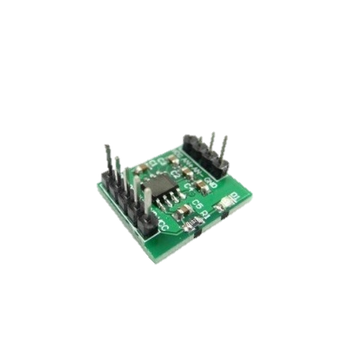 | For low load-cell output changes and stable digital conversion with reduced quantization noise, a 24-bit ADC offers the necessary resolution.
7 | Cell Excitation Regulator | 1 | - Selectable 5 V / 10 V excitation;  - ripple <10 mVpp; load current ≥50 mA;  - regulation error <1 %. |  | Consistent load-cell sensitivity and linearity are guaranteed by a controlled 5/10 V excitation, which also avoids measurement variance caused by supply drift.
8 | Touchscreen Display | 2 | - 10.1″ TFT; 1024×600 resolution; 4-wire resistive touch;  - ≥300 cd/m² brightness; 5 V supply;  - SPI/parallel interface. | 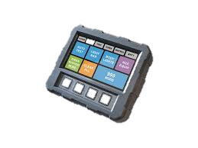 | While a vivid TFT panel guarantees visibility in different lighting conditions during field use, a resistive touchscreen allows for precise control even with gloves.
9 | Latching Push Button | 1 | - •Panel-mount latching switch;  - IP65 front; ≥1 A @ 24 VDC;  - electrical endurance ≥30 000 cycles.
10 | Internal Memory Module | 1 | - ≥8 MB SPI-NOR Flash;  - 3.3 V operation; ≥100k P/E cycles;  - data retention ≥20 years. | 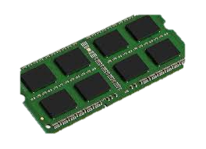 | Onboard non-volatile memory offers safe data logging independent of continuous power or external devices.
11 | USB-A Port | 1 | - USB-A female connector;  - USB 2.0 compliant;  - rated ≥500 mA;  - insertion life ≥1500 cycles. |  | A USB-A interface provides universal compatibility for exporting calibration data across service environments.
12 | Power Regulator | 3 | - Linear/DC-DC regulator stage;  - 5 V and/or 3.3 V /5.5V/10V outputs;  - ripple <20 mV;  - regulation <2 %;  - continuous output ≥500 mA. |  | Dedicated low-ripple regulators maintain stable 5 V and 3.3 V rails, therefore preventing noise injection into delicate analog circuitry.
13 | USB-C Port | 1 | - USB-C receptacle;  - 5 V input;  - mechanical retention ≥8 N;  - compliant with USB Type-C geometry. |  | A USB-C charging interface ensures compatibility with modern power sources and guarantees safe current handling.
14 | Battery Charging Circuit | 1 | - Li-Ion CC/CV charging circuit;  - 5 V USB-C input;  - charge current up to 1 A;  - integrated OV/OC/OT protection. |  | A dedicated Li-Ion charging IC ensures safe CC/CV charging behavior and prevents battery degradation or hazardous operation.
15 | Battery | 1 | - Li-Ion battery ≥5000 mAh;  - discharge capability ≥2 A;  - integrated protection (BMS);  - IEC-compliant cell pack. | 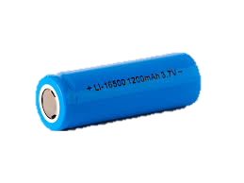 | A high-capacity Li-Ion battery ensures sufficient field autonomy, enabling extended operation without external power.
16 | Misc | 1 | - Mixed electronic passives: 1 % metal-film resistors;  - X7R ceramic capacitors;  - inductors with adequate Q-factor;  - insulated copper wire rated ≥60 V and −20…80 °C;  - 2.54 mm pin headers or board-to-wire connectors. |  | Industry-standard passives and shielded wiring ensure stable analog performance, low noise, robust insulation, and reliable board-to-board interfacing.

Mechanical Parts

 |  |  |  |  | Justification
1 | Protective Carrying Case | 1 | - Polypropylene copolymer case;  - IP67 rating;  - pressure equalization valve;  - internal dimensions ≥420×280×150 mm;  - impact-resistant hinges and latches. | 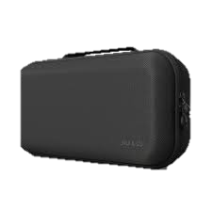 | A rugged IP67 case protects the entire system from dust, water, shock, and transport damage during field deployment.
2 | Foam | 1 | - EVA/PU foam inserts; density ≥30 kg/m³;  - CNC/laser-cut cavities;  - compression-set resistant;  - thickness matched to internal case profile. |  | Custom-cut EVA/PU foam provides precise support for each load cell and electronic component, minimizing vibration and mechanical stress.
3 | 1-Panel Frame | 1 | - Aluminium/steel front panel;  - 2–3 mm thickness;  - anodized or powder-coated;  - cut-outs for display, button, LED;  - mounting pattern aligned with internal frame. | 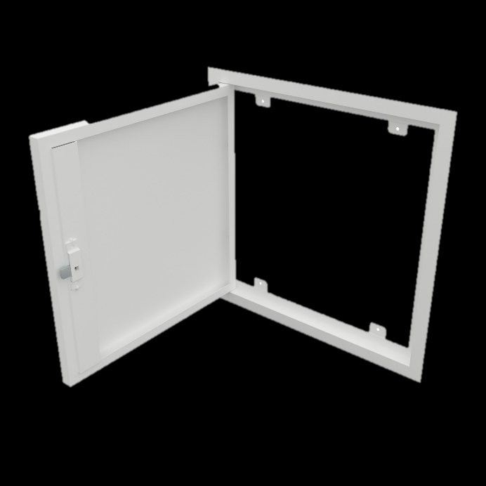 | A rigid front panel provides secure mounting for the display and controls, preventing misalignment and improving long-term usability.
4 | M4 x 12 Button Head Screw | 12 | - ISO 7380
7 | M3 x 10 Button Head Screw | 4 | - ISO 7380
8 | M3 x 8 Button Head Screw | 12 | - ISO 7380
9 | ST3.5x9.5 Tapping Screw | 4 | - DIN 7049
10 | M3 Hex Nuts | 16 | - ISO 4032
11 | M4 Washer | 12 | - ISO 7092
12 | M3 Washer | 16 | - ISO 7092
13 | Roll 20mm Wide Velcro | 1
14 | PVC Foam Tape | 1 | - 10mm Wide,  - 2mm Thickness,  - 1.16m
15 | M4X9.2 | 12 | - ACPTH 20 Zinc Plated

